 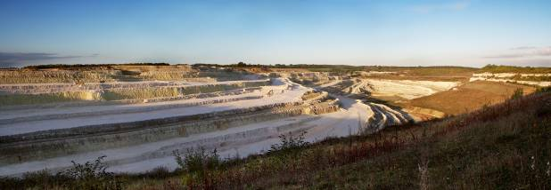

**Home Counties North Regional Group**

**A brief history of life in 10 fossils**

**Dr Paul Taylor**

**Natural History Museum**

The history of life is written in the rocks, or more precisely in the fossils contained within the rocks. This talk will showcase 10 important fossils that either represent milestones in the development of life on earth, or provide key evidence about the processes of evolution. They also tell human stories of discovery, interpretation and misinterpretation.

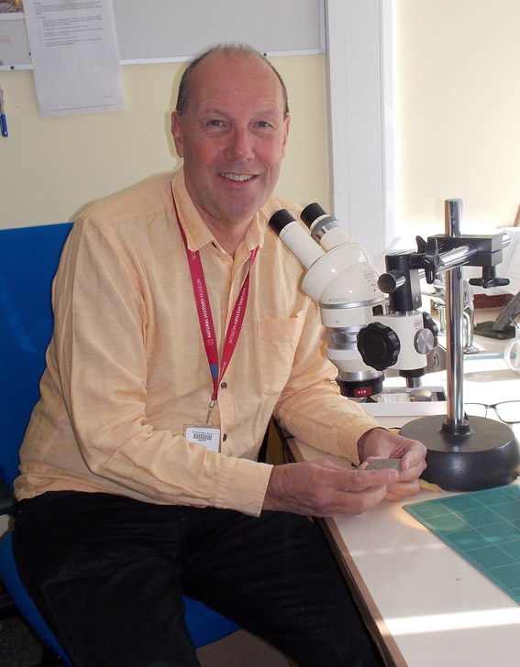 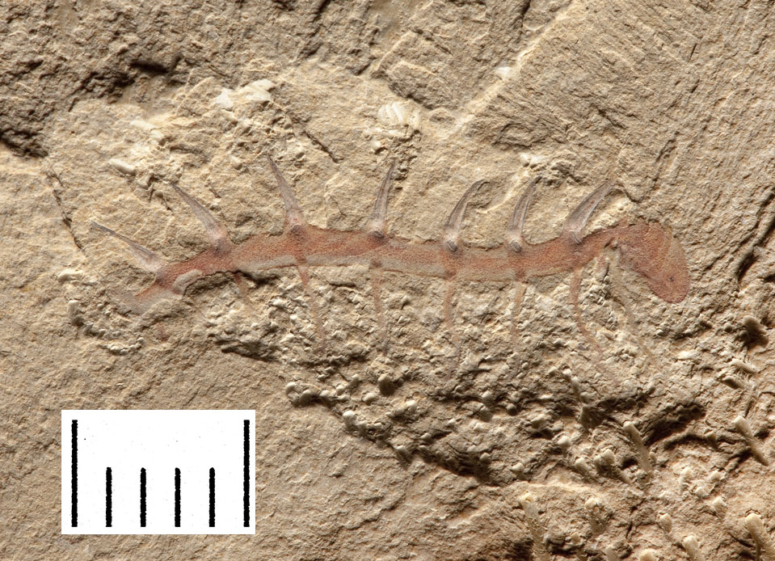 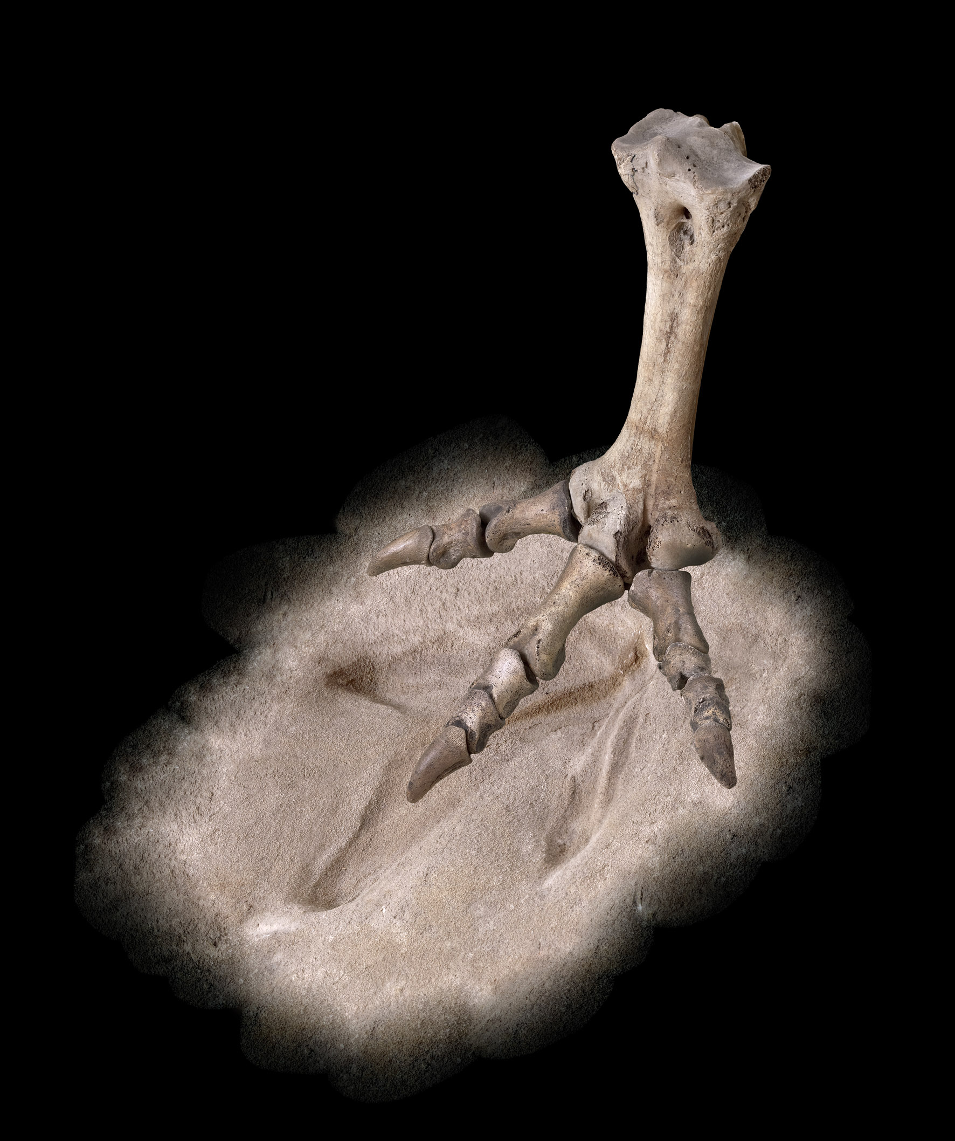

Paul Taylor is a research palaeontologist specialising on bryozoans. He is a graduate of the University of Durham and stayed there to complete a PhD (1977) in the Department of Geological Sciences before moving to the University of Swansea for a postdoctoral research fellowship. Paul has worked at the Natural History Museum in London since 1979 and has published more than 300 scientific articles as well as three popular books, the latest of which is *A History of Life in 100 Fossils* (Taylor & O’Dea, 2014. Natural History Museum Publications). He is also the Editor-in-chief of the *Journal of Systematic Palaeontology*.

**Date: Thursday 17 March 2016**

**Venue: Sir Robert McAlpine**

**Eaton Court, Maylands Avenue, Hemel Hempstead HP2 7TR**

**Refreshments 18.00**

**Lecture starts 18.30**

For more information on the Home Counties North Regional Group visit the website at <http://www.geolsoc.org.uk/hcnrg>

